Below steps are to remove old disk attached to root from data disk

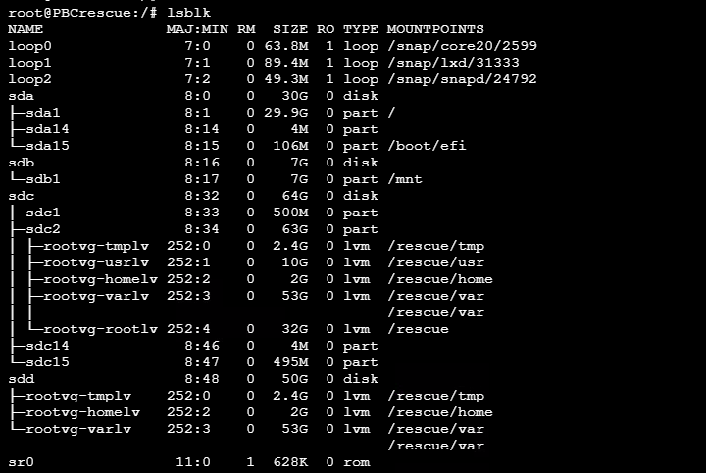

Go to OS disk and form he settings >> size + performance and change disk size from portal
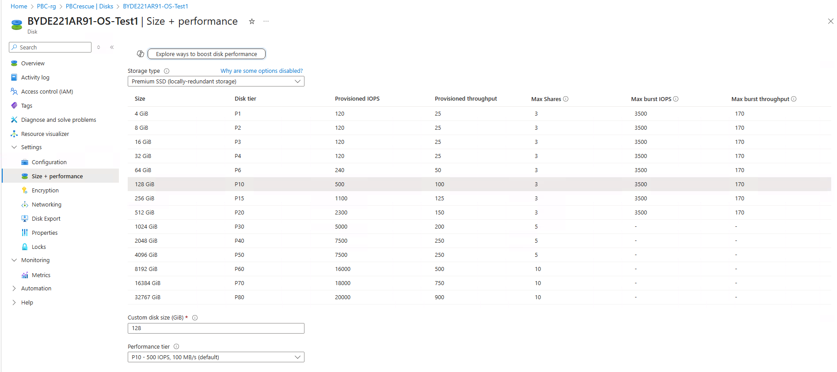

Login to server and identify the physical volume and resize the PV
#pvresize /dev/sdc
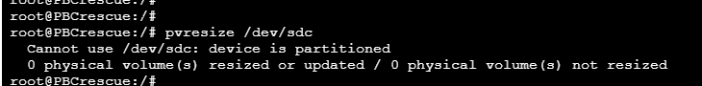

Validate disk extension
#lsblk
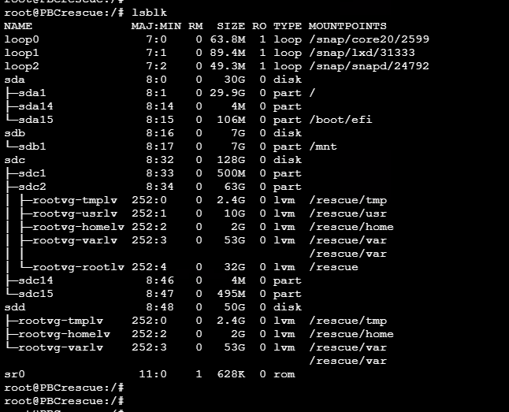

Check partition table

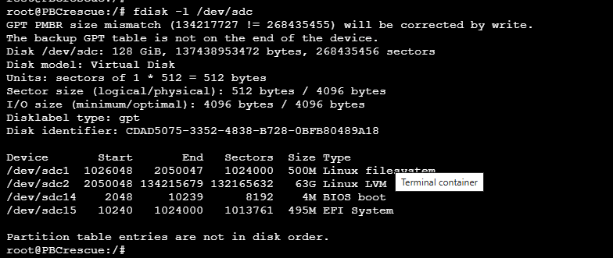

Now we need to partition the /dev/sdc disk to create new partition /dev/sdc3
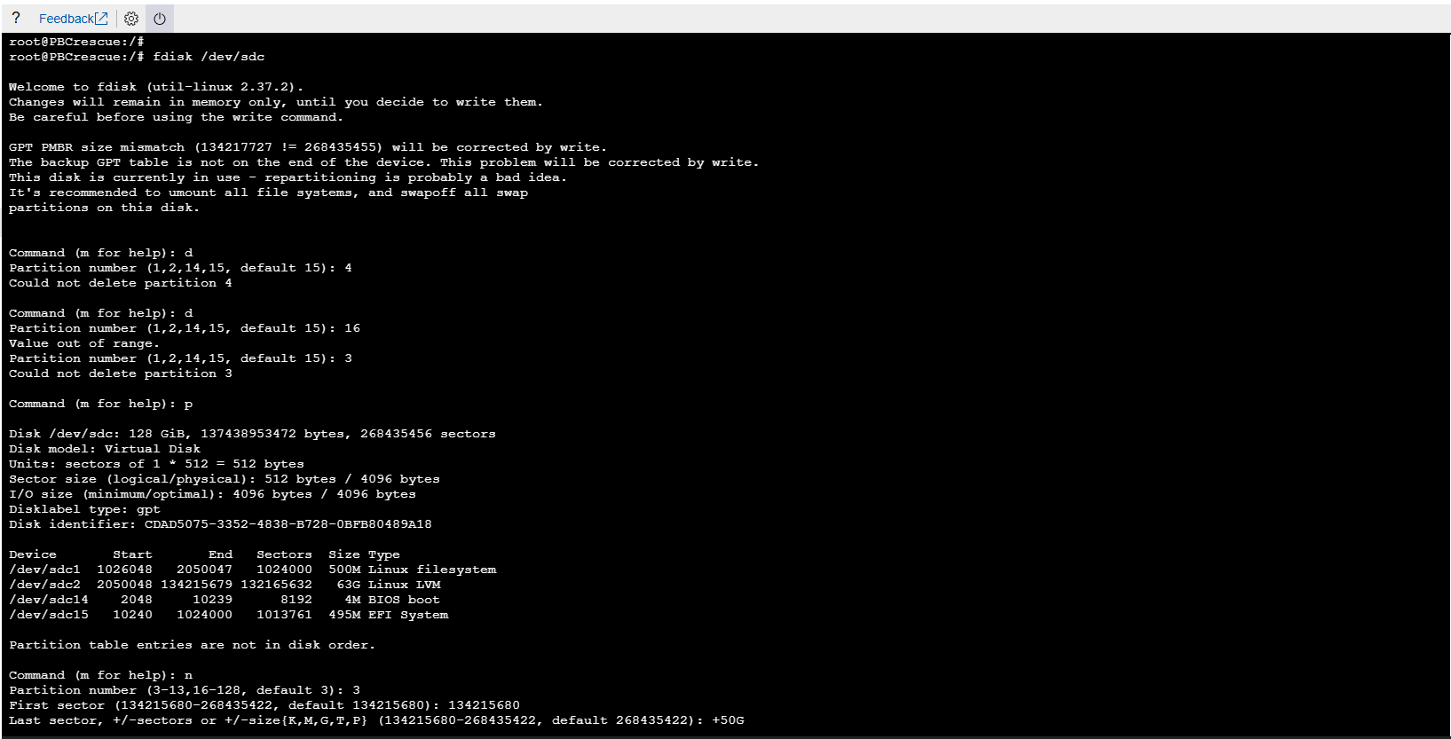

Validate partition table new partition /dev/sdc3 created or not
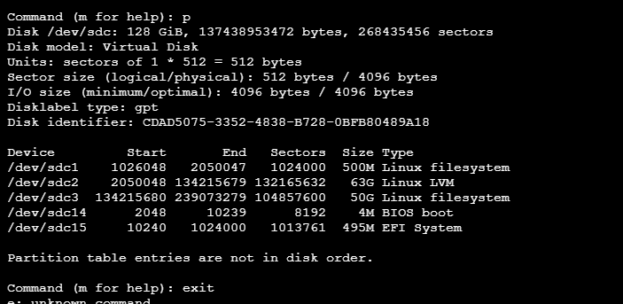

Once SDC3 created extend disk to ‘rootvg’
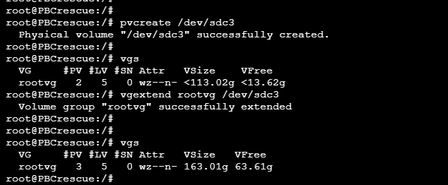

Once disk extended, please move the data from disk /dev/sdd with below command
# pvmove /dev/sdd
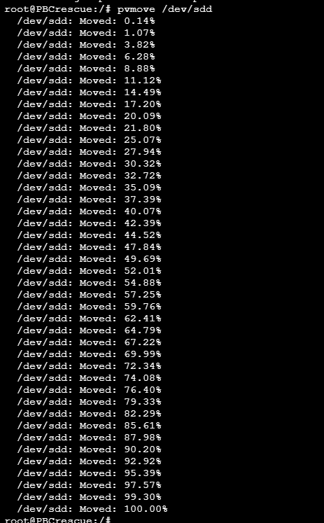

we need to remove unwanted volume
